Name: _____________
read and sequence
Cricket’s Capers

Number the events in the order in which they occurred in the story. Match the pictures with the events. Cut and paste the events and pictures. Glue them together, in order as they occurred in the book, on page 3.
Little girl put up posters.___ | Old lady gave little girl a package and smiled.___
Cricket and Izzy cuddled up to sleep.___ | Cricket’s owner was standing at the door with a man in a tie.___
A car almost hit Cricket.___ | Cricket was at the little girl’s home, and met Izzy.___
A man dressed in all white, checked Cricket out from head to toe.___ | The little girl gave Cricket water.___
Cricket charged outside to play.___ | Cricket was in a room full of dogs in crates.___

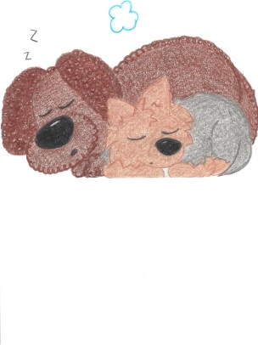 | 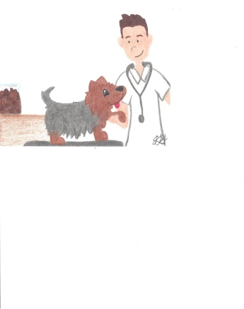 | 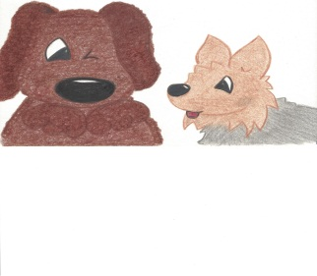 | 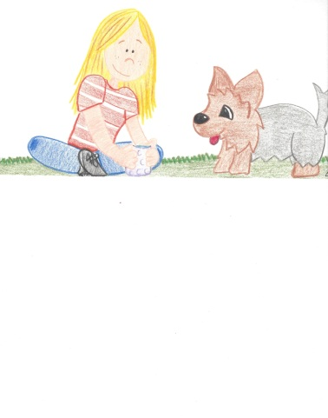
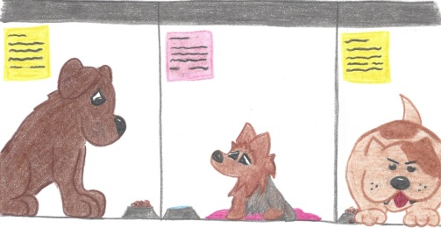 | 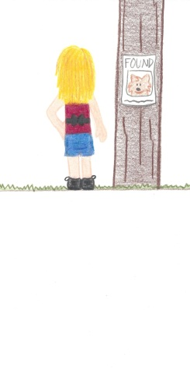 | 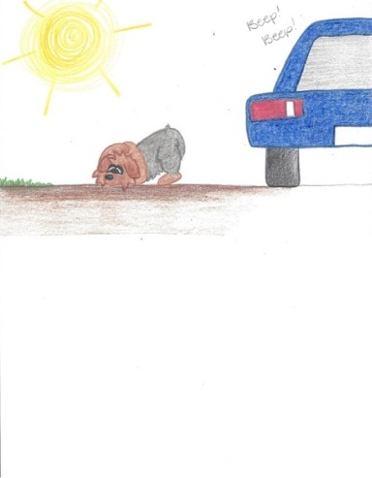 | 